Derivatives Homework

Name:

MyUH id number:

Who helped you? Who did you help?

Turn in the homework to the assignments tab in your CourseWare file. As a single pdf file.

This is a 160 point assignment. This material will included in the final.
Question 1 10 points

Write a brief illustrated essay discussing the link between the Difference Quotient and a slope. Finish with a paragraph on the meaning of the derivative from the Graph’s point of view. Be sure to include a brief discussion of increasing and decreasing as part of the graph’s point of view.

Essay Rules: no more than 2 pages, front side only, 1” margins, 12 point type – NO HANDWRITTEN WORK will be graded. Proper spelling and grammar must be used. You will be graded on style. Really.
Illustrations may have hand annotations but must have nice technologically-created main parts.

Attach the essay in between this problem and Question 2.

Question 2 20 points

Given: $f(x)=(x+2)(x−1)(x+3)$

Give the following facts about this function:

Domain

Range

End behavior – show with arrows

The x intercepts in point coordinate form

The y intercept in point coordinate form

The derivative:

Use the quadratic formula to find zeros of the derivative, list them, and discuss the implications for the graph. Use the “ish system” and report them to one decimal place or leave them as radicals in exact form.

Find the equation of the tangent line at x = 5. Put this line on your graph when you get to that part of this problem.

Show your work here:

Equation:

ATTACH the graph of this function to this sheet. Show the tangent line at x = 5 and write its slope on the line. You may sketch this tangent line in on your graph by hand but the graph must be produced using graphing technology.

Use [−4, 9] as the portion of the x-axis shown in your graph.

Have your graph illustrate information about turn-around points. Sketch in the tangent lines at the turn around points…clearly showing what you know about them.

Use the quadratic formula to find the x values of the turn-around points – leave in radical form or write as 1 decimal place “ish”s. Write in the x-coordinates of the turn around points on your graph by hand.

Use interval notation to describe where the graph is increasing and decreasing:

Discuss continuity. Where is the graph continuous? How do you know this?

Question 3 16 points

Given: $f(x)=\frac{1}{3}x^{3}+x^{2}−3x$

Use technology to sketch this graph. Attach the sketch in between this problem and Problem 4.

Use the quadratic formula to find the x-intercepts of the derivative, the turn around points. Find the coordinates of the turn-around point. List these on the graph clearly labeled.

Mark the x-intercepts, the y-intercept, and the turn-around points on the sketch with their respective coordinates. Sketch in the lines tangent to the graph at the turn around points and write in the slopes of the lines at these places.

Where is the graph increasing and decreasing? Use interval notation and write this information in the space below

Where is the graph continuous? How do you know? Write the answer in the space below.

Question 4 12 points

Given: $f(x)=\frac{1}{4}x^{4}+\frac{1}{3}x^{3}−7x^{2}−\text{24}x+3$

Find the derivative:

Tell where the graph is increasing and decreasing in interval notation:

hint: −2 is a zero of the derivative.

What is the range for this graph:

Here’s the graph:

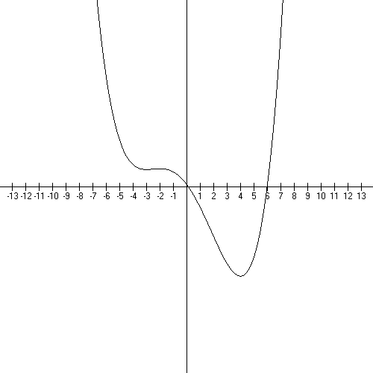

Question 5 12 points

Calculate the following derivatives. Show your work in agonizing detail.

A. $f(x)=x^{4}−2x^{3}+\text{11}x−3$

B. $f(x)={\text{14}}^{x}+2$

C.

D. $f(x)=\frac{x+9}{x−3}$

Question 6 20 points

Give the following facts about $f(x)=\frac{x+\text{16}}{2−x}$

Domain

Range

all asymptotes

all intercepts

Derivative

Equation of the tangent line at x = 1.

Where is the graph increasing and decreasing?
Where is the graph continuous?
Give these answers in interval notation and with careful labeling:

Attach a technology-created graph to this sheet. You may sketch in the asymptotes by hand but the basic shape must be from a graphing program.

Question 7 10 points

Graph is below. Math GV used for creating it.

What is the domain for this function?

Where is this graph increasing and decreasing? Mark these places off on the graph and then write them out in interval notation.
Use the “ish” system…not exact numbers, just round off nicely to one decimal place.

Are there any asymptotes? How do you know?
(Be careful here, the picture is deceptive – focus on what you know of the domain!)

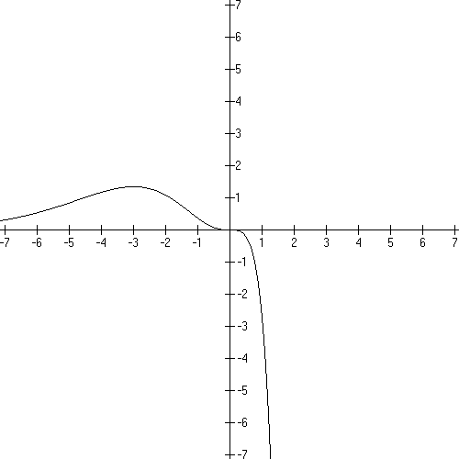

Question 8 60 points

A.
The revenue in dollars from the sale of x sound docks is given by

A. Graph the revenue curve over its domain.

B. Find the revenue for a production level of 1,100 sound docks

C. Find the average rate of change in revenue from 950 to 1,200 sound docks.
Write a brief verbal interpretation of the results.

D. Find the instantaneous rate of change at 1, 100 sound docks.
Write a brief verbal description of the results.

B.
The number of male newborn deaths per 100,000 births in France is given by

Where t is in years and t = 0 corresponds to 1980.

A. Graph this function from 1980 to 2005.

B. Find the number of newborn boys who died in 2003.

C. Find the average rate of change in mortality from 1985 to 1995.
Write a brief verbal interpretation of the results.

D. Find the instantaneous rate of change of mortality in 1995.
Write a brief verbal interpretation of the results.

C.
The number of students who graduate from high school in the US (in millions) is given by

where t is in years and t = 0 corresponds to 2000.

A. Graph this function from 2000 to 2010.

B. Give the instantaneous rate of graduation in 2005.
Write a brief verbal interpretation of the results.

D.
Given

Graph the function.

Find the slope of the secant line joining (2, f (2)) and (4, f (4)).

Find the slope of the secant line joining (2, f (2)) and (2 + h, f (2 + h)).

Find the slope of the tangent line at (2, f (2)) .

Find the equation of the tangent line at (2, f (2)) .

E.
Suppose an object moves along the y axis so that it’s location is at time t (y is in cm and t is in seconds). Find:

A. the average rate of change of y with respect to t (i.e. the average velocity) for t changing from 2 to 4 seconds.

B. the average velocity from t = 2 to t = 2 + h.

C. the instantaneous velocity at t = 2.

F.
Given . Find

A.

B. the slope of the tangent line at f (2) and f (−1/2).

C. graph f (x) and sketch in the tangent lines at x = −1/2 and x = 2.

G.
If $300 were invested in an account that earns 8% interest compounded annually, then the amount in the account after t years is given by

Find the amount after 7 years. Find and write a verbal interpretation of the number.

